## Wheat - SDM

Dimmy van Ruiten – s1385615

### Introduction

Wheat is a widely distributed crop, which is used mostly for its flour. *Triticum aestivum* is one of the oldest domesticated plants and is also called bread wheat. The domestication started 10.000 years ago in the Middle-East and in Africa. Since then, the properties of wheat and the use in bread and other products caused the crop to spread over the globe. Wheat is now the number one used crop in the world, next to mays and rice.

*Triticum* is a monocot from the family of Poaceae. Hereunder a map of the current distribution of *Triticum aestivum* is included. 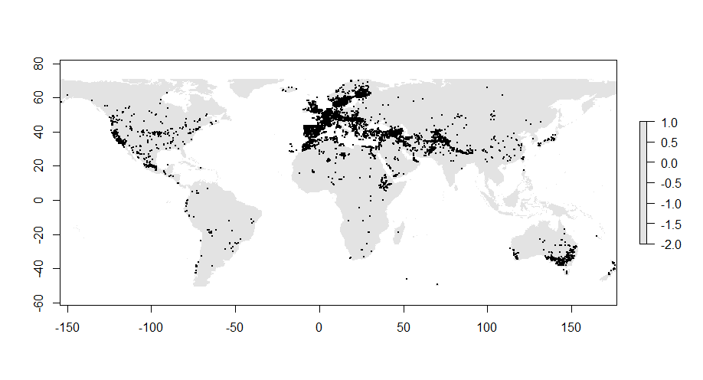

Figure 1. Current distribution of Triticum aestivum.

### Methodology

In the following analyses, prediction are made upon the future distribution of common wheat. The current distribution and extensive climate models are used to make a prediction.

Several steps are needed to make this prediction. At first, the current species occurrence data is needed. This data is downloaded from GBIF.org. Then, climate data is downloaded from worldclim.org. For the current climate data, the 5 minute 1.4 version is used. The 2050 ACCESS1-0, rcp45, bi version is downloaded for the future climate models.

Before we can use MAXENT to make the species distribution model, we need to clip and format the model in R. We need to make sure that the climate variables are not correlated with each other. The model is trimmed from variables one by one, until only four variables are left. Those are Mean Diurnal range, Minimal Temperature of the Coldest Month, Precipitation of the Wettest Quarter and Precipitation of the Driest Quarter. Those variables were chosen because they gave the best representation of variables whereby there were no correlated variables. Two temperature related terms are included and two precipitation variables are in there as well.

Then, the model is loaded in MAXENT and the correct settings are set. In the analysis, auto features is checked. This means that all the features are combined in the process. The more features used, the more complicated the model, the bigger the risk of overfitting. It is also an option to only use two features, like Linear and Quadratic.

### Model Output

The results of the Species Distribution Modelling are described and presented hereunder.

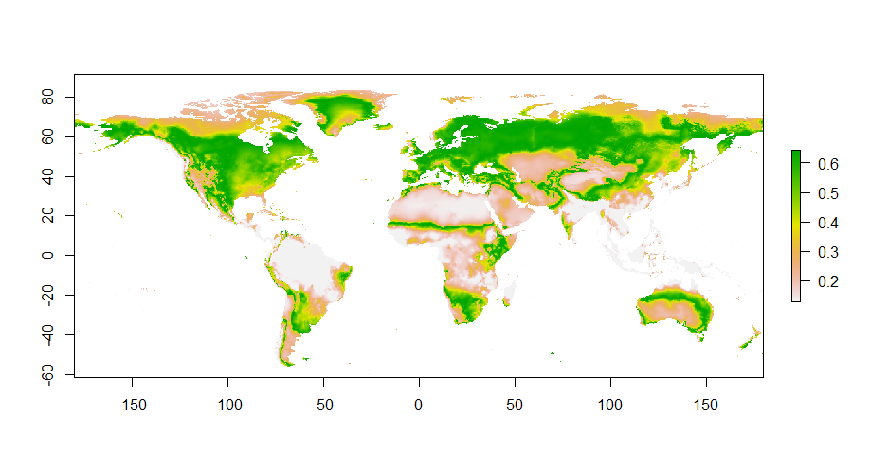

Figure 2. Present global species distribution

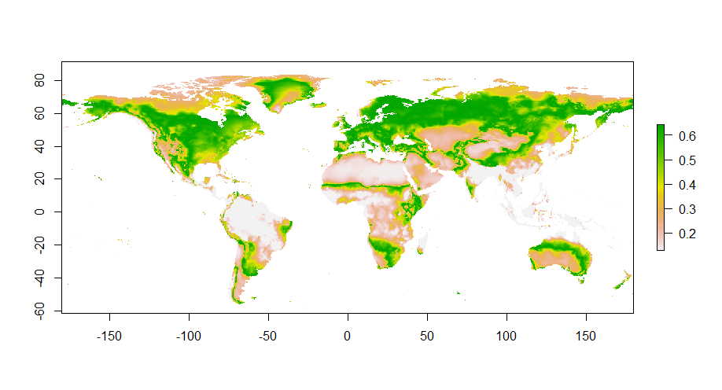

Figure 3. Future global species distribution

There are no clear noticeable differences between the distributions upon the first look at the maps. *Triticum aestivum* is already widely distributed and that will not change according to the model.

### Model performance

To validate the model, the Area Under the Curve is measured. The AUC for the used model is 0.716. This suggests that the model is reliable and interpretations from the model can be made. However, because presence-only data is used, the model should be tested against a null-model. This will not be done during this analysis due to the complexity.

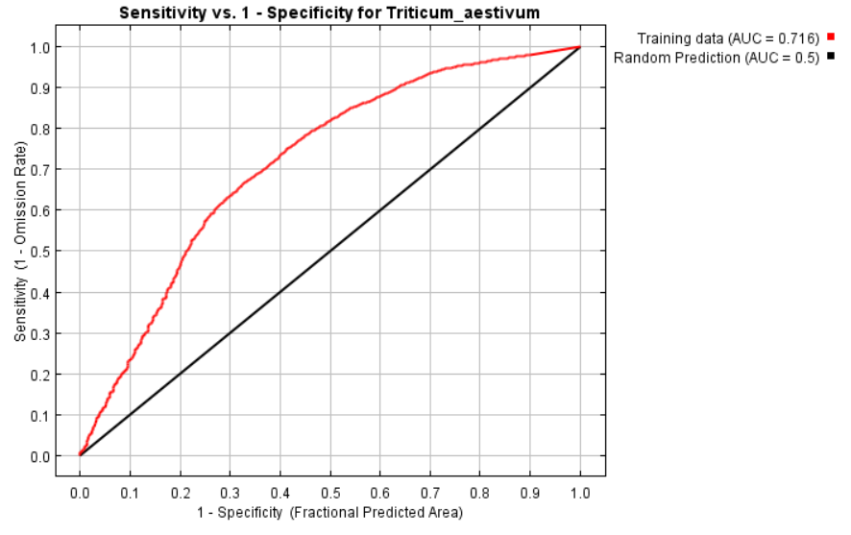

Figure . AUC graph

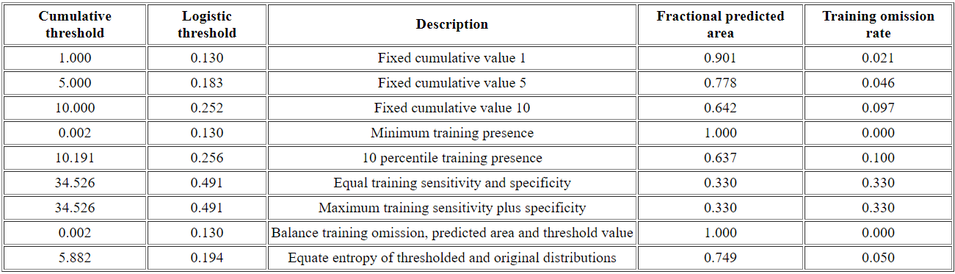

Figure 5. Threshold table. Maximum training sensitivity plus specificity = 0.491

### Variable contribution

The different variables all contribute to the model differently. Some variables are more important than others. As is shown in the graphs and in the table, bio16 clearly has the biggest contribution. bio16 is the Precipitation of the Wettest quarter.

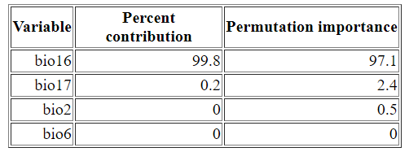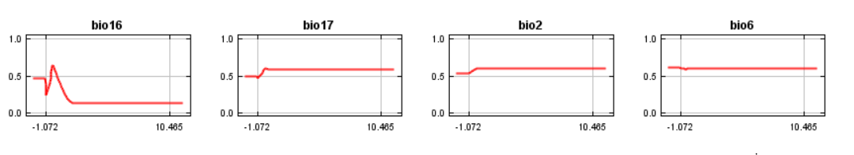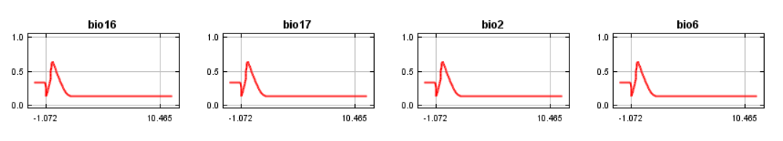

Figure 6. Variable contribution table.

Figure 7. Variable contribution graphs.

### Response to Future Scenario

The model calculates whether a habitat is suitable for the chosen species. For *Triticum aestivum* there is almost no change in habitat suitability. The threshold is chosen from the threshold table and is set at 0.491.

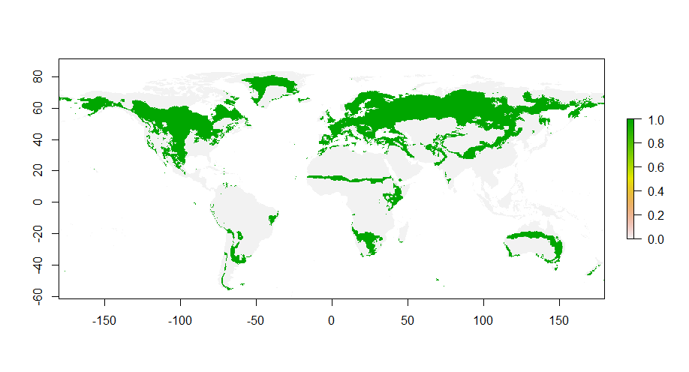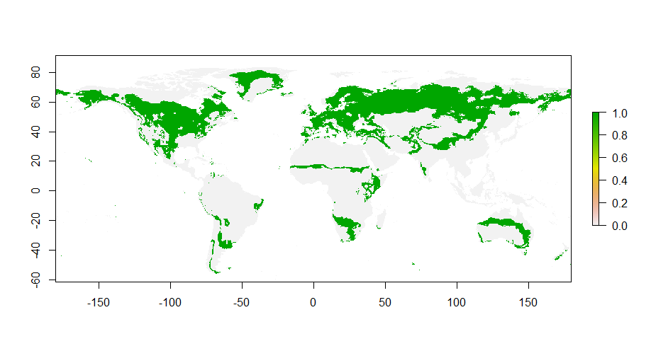

Figure 8. Present and future habitat suitability.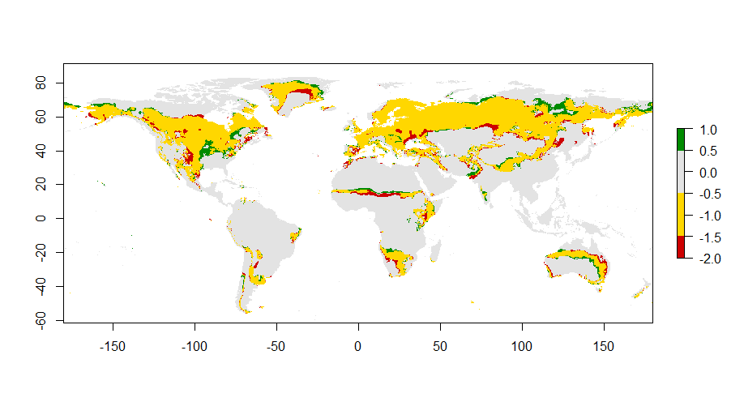

Figure 9. Range change between present and future.

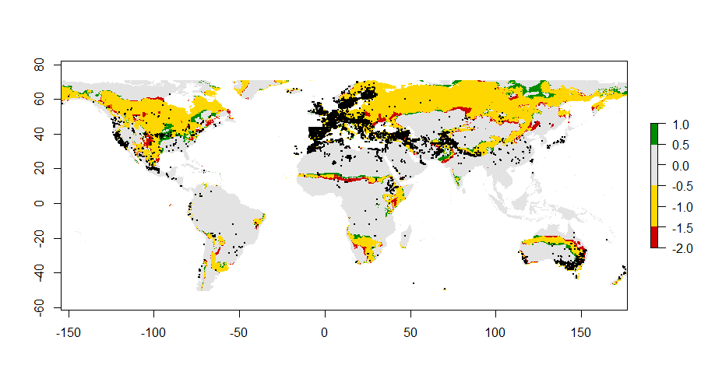

Figure 10. Current species occurence plotted against range change.

### Biological interpretation

*Triticum aestivum* is already widely distributed and has many suitable habitats. The changes in distribution are only minor. What is noticeable, is that there is a slight shift to the north. This could be linked to rising temperatures and change in precipitation.

For this species, a distribution model made with this model is not really that useful in my opinion. It could be better if more information would be included. Not only the occurrence for instance, but also the time in which it is spreading over the globe. With these settings you don’t know if the crop has been so widespread for a while, or only for the last few years. This could be important for the analysis.

For other species which are more rare and are more dependent from their habitat the model could work well.